Name: Nathanial Amador

Student ID: 1215332092

Date: 2/20/2022

**Instructions:** Answer the following questions using complete sentences. You should use these questions to have a written discussion about the website you are going to design for the topic you submitted for Project Submission 1.

**1. Website Goal***Describe the goal of your website in one or two sentences.*

The goal of my website is to create a portfolio for my physical and digital art pieces.

**2. What results do I want to see?***List the page name (that will be used in the nav section, e.g. Home, Yurts, Contact, etc.) and a brief description of that page on your site. You will need to have seven to eight pages listed.*

Home – A inviting looking webpage meant to hook the viewer. I want to pique curiosity.

About Me – Short explanation of my background and experience as an artist  
Programming – Set of my favorite programming pieces (done in p5js)  
Painting – Set of my best painting pieces  
Drawing – Set of my best Drawing pieces

Shop – Catalog of pieces that I am currently selling that the viewer can click on and hopefully purchase (worst case if I can’t get this to work, I can have it link to an Esty listing)

Contact Me – Page where the viewer can see my social media, email, and possibly send donations via PayPal

**3. What information do I need?**  
*List where you will obtain the content (facts, text, graphics, sound, video, etc.) for the web pages you listed above. If the information is from a website, list its url. Can’t just answered will google it. List out this information separately for each page you listed above.*

The portfolio images will all be my art. For the P5JS programming it is all Javascript so I can just inject it into the webpage (if it runs poorly when I inject it directly, I can take a video and then link the code under).

**4. What color scheme will you use for your site?**

*Go to paletton.com and select a color scheme your like. Play around with the different type of color combinations.* ***Choose a Triad or Tetrad combination, this will provide you will several colors for your website.*** *When you find one that you like,* ***screenshot the Pallet UID and the image and paste them in the space below****. Make sure you include the url that’s where the UID is located. Example is on the next page.*

PalletID: [50h0-0kzDHlktLvqmIHGStOHYn8](http://paletton.com/#uid=50h0-0kzDHlktLvqmIHGStOHYn8)



**5. How will your project use a form?**

*Describe how you plan to use a form in your project to collect viewers’ inputs or information. Examples of using a form might be to offer feedback, provide a survey or poll, offer subscriptions to a newsletter, etc. Describe what information you will want to collect from your viewers and the importance of each piece of information.*

I will create a form to sign up for a newsletter for my art. I will update people when I am hopefully showing work at galleries as well as sales on my store!

Color Scheme Example:

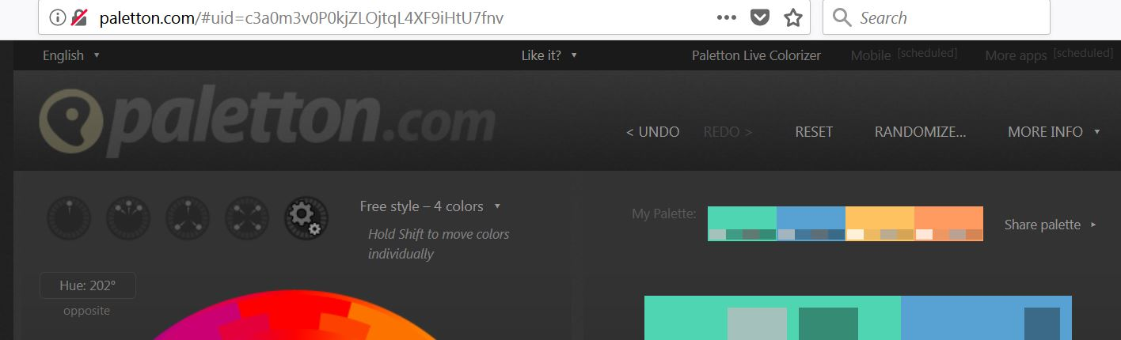

Palette UID: [6300E0kuDsfjIzJoXu+wmmFDMh-](http://paletton.com/#uid=6300E0kuDsfjIzJoXu+wmmFDMh-)

[](http://paletton.com/#uid=6300E0kuDsfjIzJoXu+wmmFDMh-)